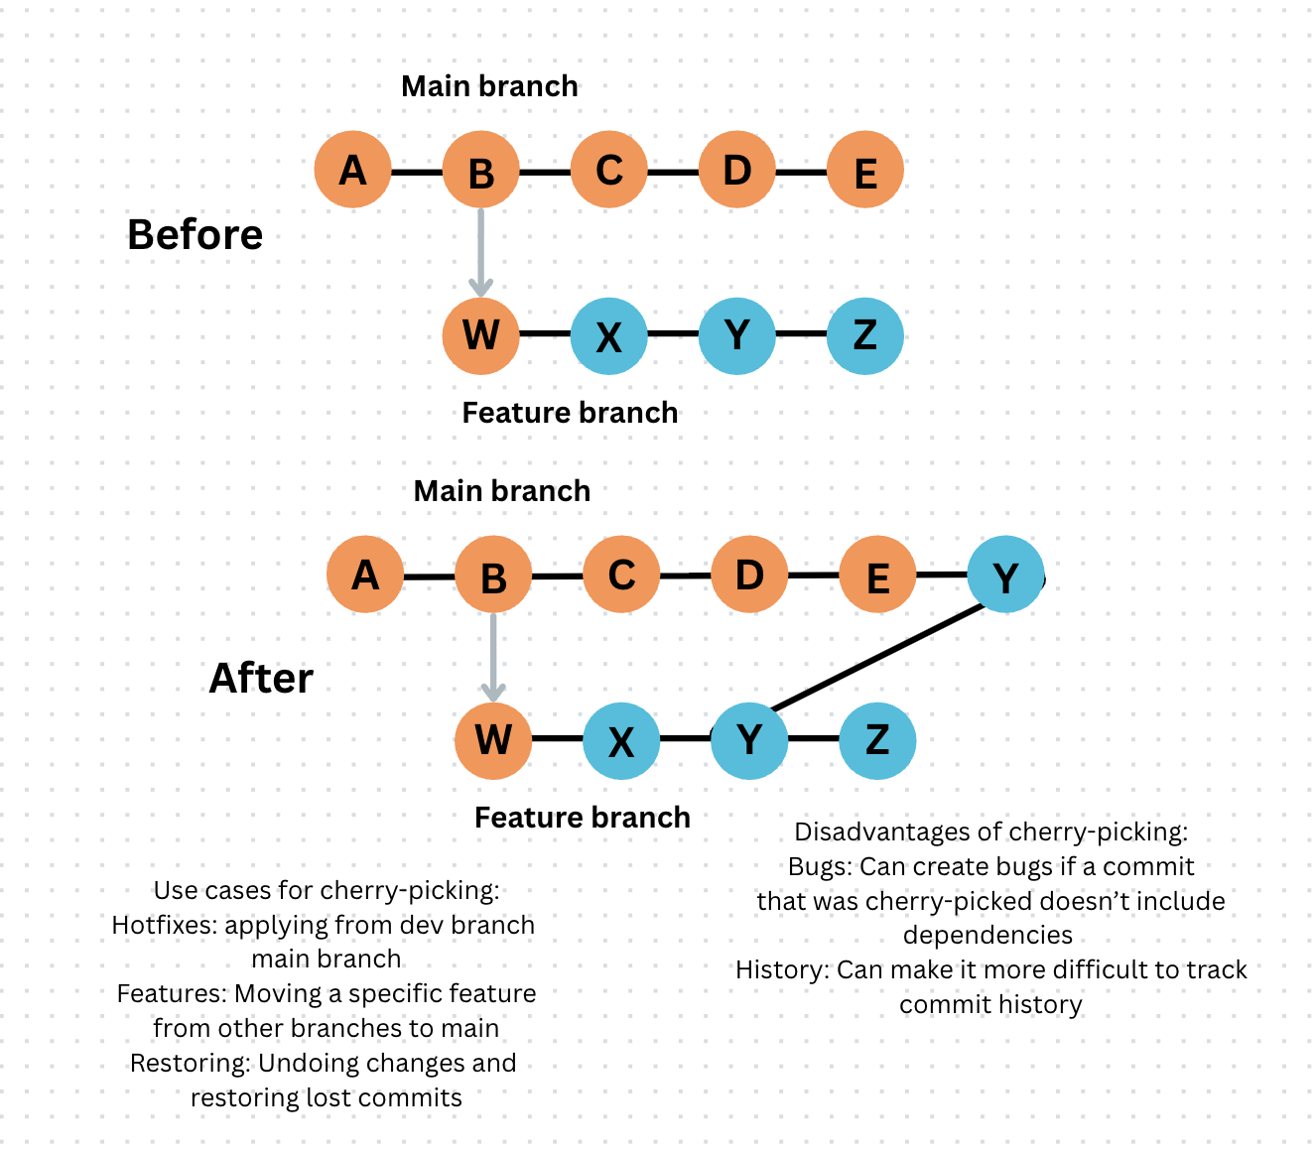
exercise 1 git cherry-picking

exercise 2 git clean
- preview changes: git clean -n dry run lists files for deletion without removing them
- remove untracked files: git clean -f force deletes files
- remove untracked directories: git clean -fd deletes both untracked files and folders
- interactively remove files: git clean -i selective deletion through interactive terminal menu
- remove ignored files: git clean -x deletes untracked files including those listed in .gitignore

